Cybersecurity Risk and Incident Analytics Dashboard for SMEs
1. Introduction
This project presents a cybersecurity risk and incident analytics dashboard for a fictional small-to-medium enterprise named RetailPro SME Ltd. The company operates in the e-commerce and retail sector and uses systems such as Microsoft 365, a CRM platform, an inventory system, an HR portal, a web server, and customer support tools. The main purpose of the project is to convert simulated cybersecurity data into management-level insights that support better decision-making.
Small and medium-sized businesses often face cybersecurity challenges but may not have mature security reporting processes. Technical logs, incident records, and vulnerability scan results can be difficult for non-technical managers to interpret. As a result, important risks may remain unclear or unresolved. This project addresses that problem by using Power BI to analyse cybersecurity incidents, vulnerabilities, assets, business risks, and ISO control recommendations in a structured dashboard format.
The dashboard is designed to support both technical and business users. It helps identify the most common incident types, the most affected departments, the most vulnerable assets, and the highest-priority business risks. The project also demonstrates how cybersecurity, business intelligence, data analytics, and governance, risk, and compliance concepts can be combined into a single practical portfolio project.
2. Project Aim and Objectives
2.1 Aim
The aim of this project is to analyse simulated cybersecurity incidents, vulnerability records, asset information, and risk register data for an SME environment, and to convert this information into actionable business insights through a Power BI dashboard.
2.2 Objectives
The objectives of this project are:
- To create a simulated cybersecurity dataset for an SME environment.
- To analyse security incidents by severity, department, system, and incident type.
- To evaluate vulnerability exposure using CVSS score, patch status, and affected assets.
- To develop a cybersecurity risk register using likelihood, impact, and risk score.
- To map key risks to ISO/IEC 27001:2022 Annex A controls.
- To build an interactive Power BI dashboard for management-level reporting.
- To recommend mitigation actions based on data-driven findings.
3. Dataset Description
The project uses five simulated datasets: incidents, vulnerabilities, assets, risk register, and control mapping. These datasets were created to represent a realistic SME cybersecurity reporting environment.
Dataset | Description
Incidents | Contains simulated cybersecurity incident records including incident type, severity, department, system, status, resolution time, and business impact.
Vulnerabilities | Contains vulnerability records including asset ID, vulnerability description, CVSS score, severity, patch status, owner, and discovered date.
Assets | Contains asset details such as asset name, asset type, department, criticality, internet-facing status, and owner.
Risk Register | Contains business risks scored using likelihood, impact, risk score, risk level, status, and department.
Control Mapping | Maps each risk to an ISO/IEC 27001:2022 Annex A control and a recommended mitigation action.
The dataset is simulated and was created for portfolio and learning purposes. It does not contain real company, customer, employee, or security data. This makes the project safe to share publicly while still reflecting realistic cybersecurity reporting scenarios.
The relationships between the datasets were designed to support meaningful analysis. Vulnerability records are linked to assets using asset_id, while control mapping records are linked to the risk register using risk_id. Incident records are connected to systems using the system name, allowing incident patterns to be analysed against affected business systems.

4. Data Quality and Preparation
Before building the dashboard, the dataset was checked for data quality issues. The validation process focused on completeness, uniqueness, validity, consistency, and referential integrity.
Completeness checks ensured that required fields such as incident ID, vulnerability ID, asset ID, risk ID, and mapping ID were not blank. This was important because missing identifiers would make it difficult to track records and create reliable relationships in Power BI.
Uniqueness checks confirmed that key identifiers such as incident_id, vuln_id, asset_id, risk_id, and mapping_id did not contain duplicate values. Duplicate identifiers could cause inaccurate counts, incorrect relationships, and misleading dashboard results.
Validity checks confirmed that numerical values were within expected ranges. CVSS scores were checked to ensure they remained between 0.0 and 10.0. Likelihood and impact scores in the risk register were checked to ensure they remained within the expected range of 1 to 5.
Consistency checks were used to confirm that CVSS scores matched the correct severity classification. Scores from 9.0 to 10.0 were classified as Critical, scores from 7.0 to 8.9 as High, scores from 4.0 to 6.9 as Medium, and scores below 4.0 as Low. The risk score calculation was also checked to ensure that risk_score was equal to likelihood multiplied by impact.
Referential integrity checks confirmed that vulnerability records correctly matched existing assets using asset_id, and that control mapping records correctly matched existing risks using risk_id. These checks helped ensure that the Power BI relationships would work correctly.
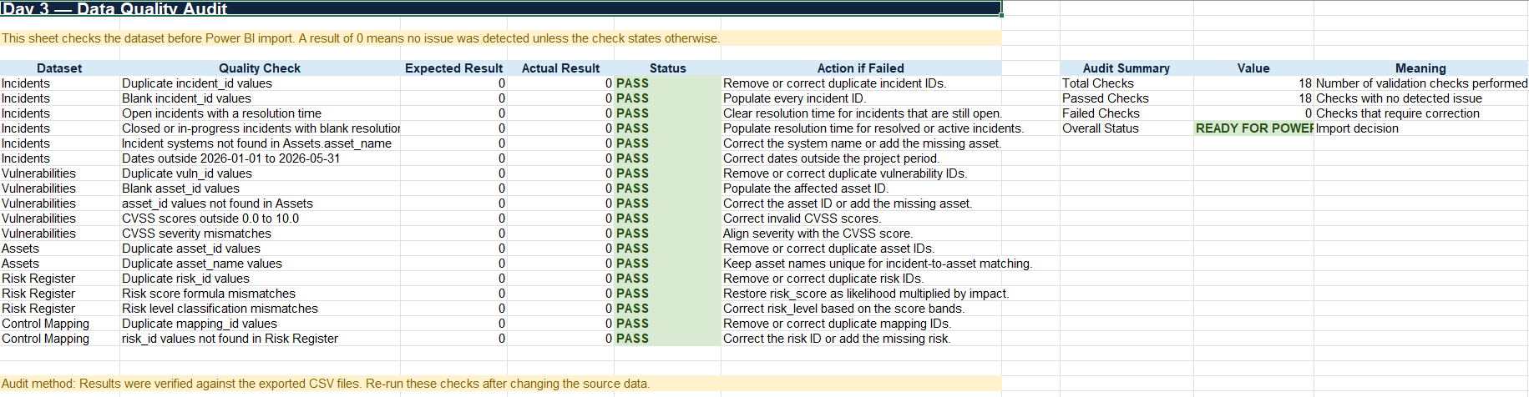
The final data quality audit showed that all validation checks passed and that the dataset was ready for Power BI modelling and dashboard development.

5. Dashboard Design
The dashboard was designed with four report pages. Each page addresses a different level of cybersecurity analysis.
5.1 Executive Overview
The Executive Overview page provides a high-level summary of the organisation’s cybersecurity posture. It includes key performance indicators such as total incidents, high and critical incidents, open incidents, and average resolution time. It also includes charts showing monthly incident trends, incidents by severity, most affected departments, and incident status breakdown.
This page is intended for management users who need a quick and clear view of the overall security situation.
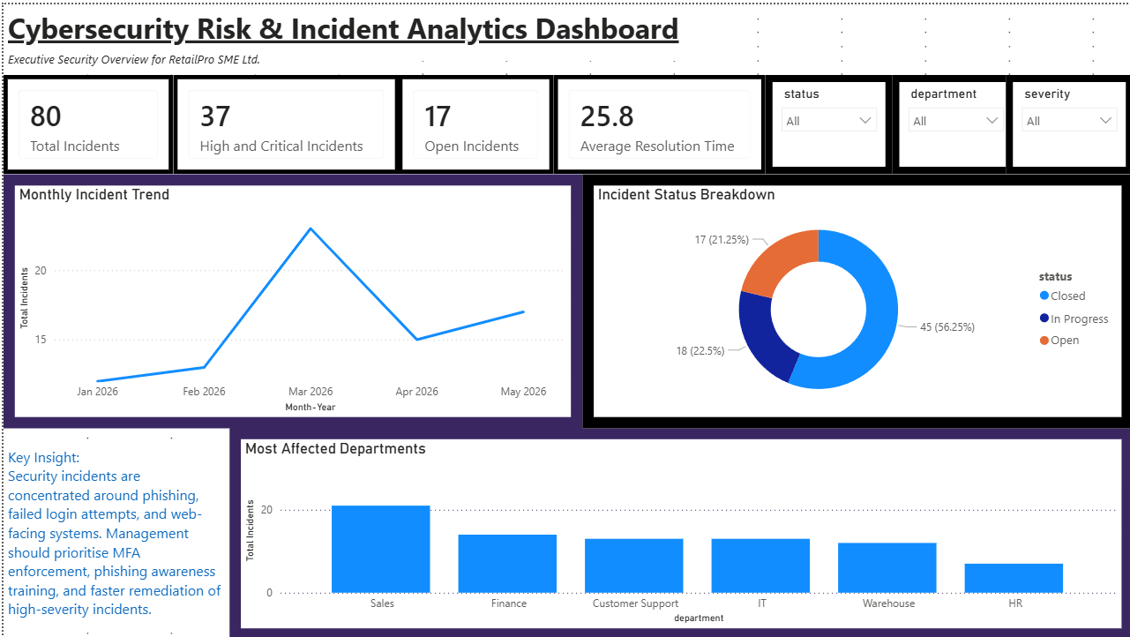
5.2 Incident Analysis
The Incident Analysis page provides a more detailed view of cybersecurity events. It analyses incidents by type, severity, department, status, and resolution time. This page helps identify the most common incident patterns and which business areas require operational attention.
The page also includes an incident detail table, allowing users to review individual records behind the dashboard visuals.
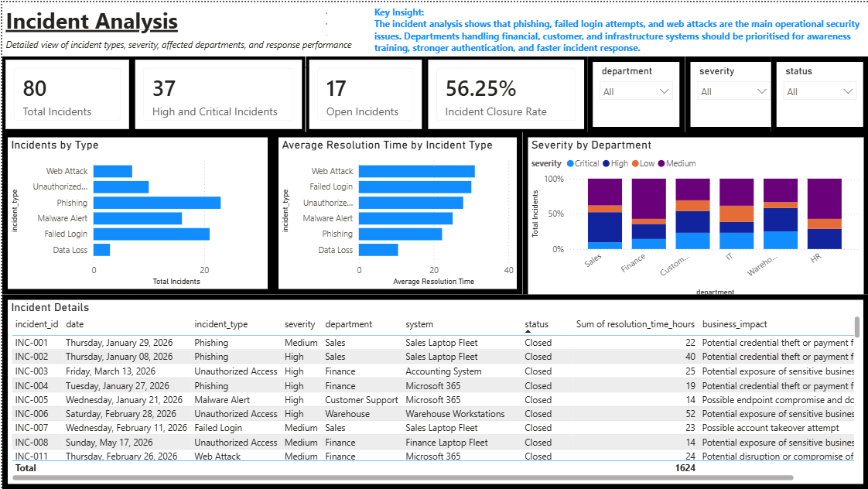
5.3 Vulnerability and Asset Risk
The Vulnerability and Asset Risk page focuses on technical exposure. It analyses vulnerabilities by severity, patch status, affected asset, asset type, CVSS score, and internet-facing status. This page supports patch prioritisation and technical remediation planning.
A key feature of this page is the internet-facing high-risk vulnerabilities table. This table helps identify vulnerabilities that should be prioritised because they affect externally reachable systems and have high or critical severity.
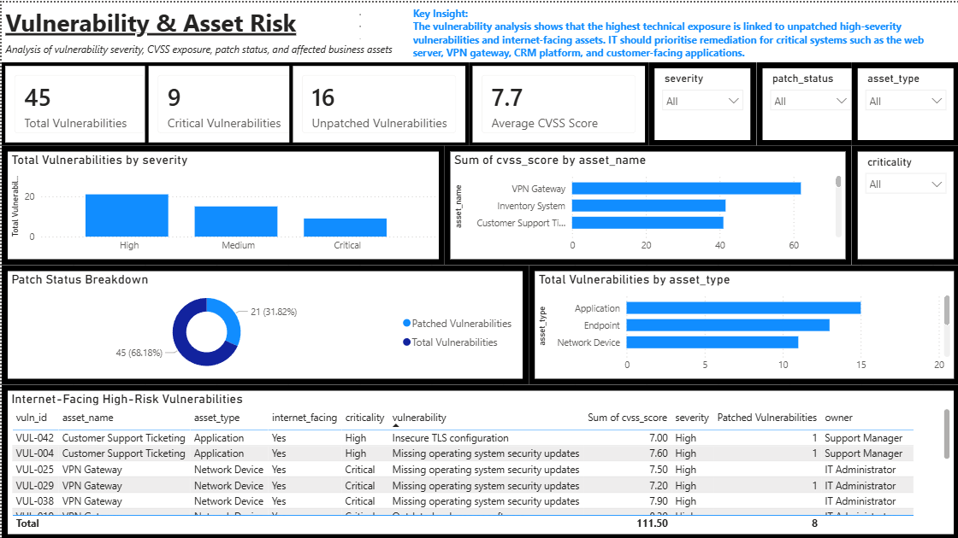
5.4 Risk Register and Controls
The Risk Register and Controls page connects cybersecurity issues to business risk. It shows risk scores, risk levels, risk status, ISO/IEC 27001 control mapping, and recommended mitigation actions. This page is useful for GRC and IT risk reporting because it translates technical issues into business-focused priorities.
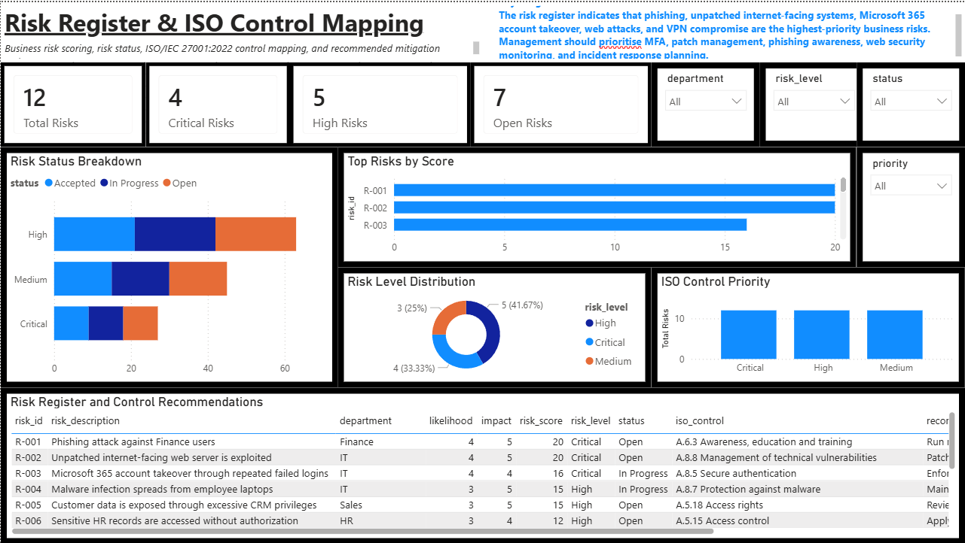
6. Key Findings
6.1 Incident Concentration
The incident analysis showed that phishing, failed login attempts, and web attacks were among the most frequent cybersecurity events in the simulated SME environment. This suggests that user awareness, authentication controls, and web-facing security monitoring are important priorities for the organisation.
6.2 Department Exposure
The dashboard showed that departments such as Finance, Sales, and IT had higher exposure to cybersecurity incidents. This is realistic because Finance handles payment and accounting processes, Sales uses customer-facing CRM systems, and IT manages critical infrastructure and administrative access.
6.3 Vulnerability Exposure
The vulnerability analysis showed that high and critical vulnerabilities were present across important systems, including internet-facing and business-critical assets. Vulnerabilities with high CVSS scores and unpatched status represent the strongest technical remediation priority.
6.4 Patch Status
Patch status analysis showed that not all vulnerabilities had been fully remediated. Unpatched and in-progress vulnerabilities require management attention because delayed remediation increases the likelihood of exploitation.
6.5 Risk Prioritisation
The risk register showed that phishing, unpatched internet-facing systems, Microsoft 365 account takeover, web attacks, and VPN compromise were among the highest-priority risks. These risks were prioritised using likelihood, impact, and calculated risk score.
6.6 Control Mapping
The ISO control mapping showed that the most important recommended controls included multi-factor authentication, patch management, phishing awareness training, network security monitoring, access control review, and incident response planning.

7. Recommendations
Based on the dashboard findings, the following recommendations are proposed.
Priority | Risk Area | Recommendation | Expected Benefit
Critical | Account takeover | Enforce MFA across Microsoft 365, VPN, and administrator accounts. | Reduces risk of unauthorised access.
Critical | Unpatched systems | Patch internet-facing high and critical vulnerabilities within seven days. | Reduces external attack surface.
High | Phishing | Conduct monthly phishing simulations and targeted awareness training. | Reduces likelihood of credential theft and fraud.
High | Web attacks | Apply web application firewall rules and monitor suspicious traffic. | Improves protection of online services.
High | Access control | Review CRM, HR, and finance system permissions quarterly. | Reduces excessive privilege and data exposure.
High | Incident response | Define response SLAs and conduct incident response exercises. | Improves response speed and consistency.
Medium | Backup and recovery | Test backup recovery quarterly. | Improves resilience against data loss.
The recommendations are prioritised based on business impact, technical exposure, and feasibility for an SME environment. Controls such as MFA, patch management, access review, and awareness training are suitable for small businesses because they provide strong risk reduction without requiring overly complex security architecture.

8. Limitations
This project uses simulated data rather than real organisational security data. As a result, the findings should be interpreted as a demonstration of cybersecurity analytics and dashboard design rather than a real security assessment. The dataset does not include raw SIEM logs, endpoint telemetry, firewall events, or real vulnerability scan exports.
Another limitation is that the dashboard focuses on descriptive analytics rather than predictive analytics. It identifies current incident patterns, vulnerability exposure, and risk priorities, but it does not predict future attacks or automatically detect anomalies.
The ISO/IEC 27001 control mapping is simplified for portfolio purposes. In a real organisation, control selection would require detailed business context, legal requirements, asset classification, risk appetite, and stakeholder review.
The project also assumes that the simulated data is accurate and complete. In a real environment, data quality issues such as missing logs, inconsistent asset inventories, duplicated records, or incorrect severity classifications would need to be handled through more formal data governance and security operations processes.
9. Conclusion
This project demonstrated how cybersecurity data can be transformed into business-level insight using Power BI. By combining incident records, vulnerability findings, asset information, risk scoring, and ISO control mapping, the dashboard provides a structured view of cybersecurity posture for an SME environment.
The project shows that cybersecurity reporting should not only focus on technical alerts. It should also explain business impact, affected departments, vulnerable assets, open risks, and recommended actions. The final dashboard supports decision-making by helping management prioritise incident response, patching, authentication controls, awareness training, and risk treatment activities.
Overall, the project provides a practical example of how cybersecurity, data analytics, business intelligence, and GRC concepts can be combined into a single portfolio project. It also demonstrates transferable skills in data preparation, dashboard design, risk analysis, control mapping, and management reporting.

